Parent’s Guide to Hives

Hives is a common skin rash triggered by many things including foods, medications, and environmental irritants.
Symptoms include itchy, raised, red, or skin-colored welts on the skin's surface that look like this:
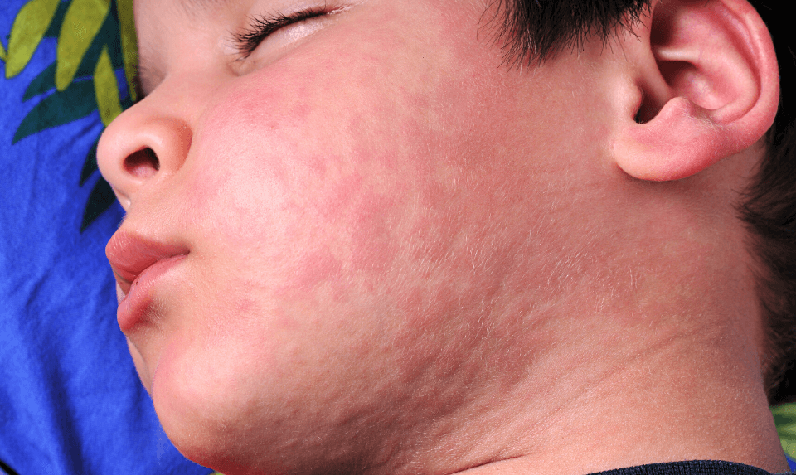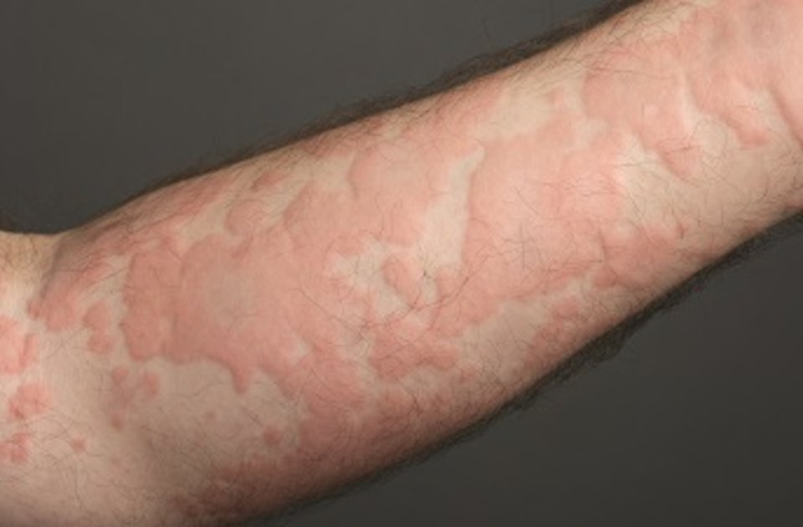

What do I do if my child gets Hives?

To relieve itching, you can take medicines called antihistamines (ex: Benadryl). Benadryl dosing can be found on our website under the “For Parents- Fever Medication and Benadryl Dosing” section. It is important to be sure of the instructions of the antihistamine that you give your child. Benadryl lasts 4-6 hours.

You should take your child to the ER if any of these symptoms occur:

- trouble breathing
- tightness in the throat
- nausea or vomiting
- cramps or stomach pains
- passing out
- swelling of the face, hands, feet, or genitals
